CURRICULUM VITAE
Charles Morel (Mr.)
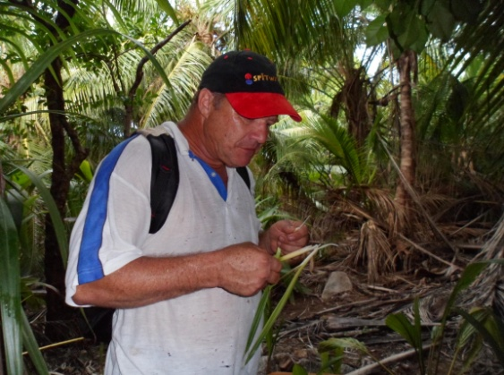
Herbarium Curator (National Herbarium Seychelles)
Date of Birth 21 February 1964
Nationality Seychellois
Sex Male
Status Married
Address Quincy Village, Mahé, Seychelles
Phone Number +248 2520596/+248 2822325

EDUCATION
Jan 1976-Dec 1980 Seychelles College Grammar School
Certificate GCE Cambridge ‘O’ Level
(Engluish, French, Mathematics, Art)

Jan 1970-Dec1975 Seychelles College Primary School

Professional Training
Jan 1982-Dec 1984 Seychelles Polytechnic
Certificate in “Science Laboratory Technology Phase I” (Distinction)

Jan 1985-Dec 1986 Seychelles Polytechnic
Certificate in “Science Laboratory Technology Phase II” (Distinction)
March 1993 National Museum of Natural History, New Delhi, India
Internship training in Museology

November 1998 Mombasa, Kenya
Workshop on Deterioration of Collections

July 1999 Natural History Museum, London
Short course on Collections Management and education Outreach

June 2000 Ministry of Environment, Seychelles
Course on Herbarium Techniques,

September 2001 10th PREMA course, Mombasa, Kenya
Preventive Conservation and Care of Collections

December 2002 Seychelles Institute of Management
Course in Supervisory Skills Development

Feb 2004 Seychelles Institute Of Management
General Certificate in Management (Distinction)

Employment

Jan 1981-Oct 1989 National Youth Service
Science Laboratory Technician (combined science)

Nov 1989-Oct 1991 Seychelles Polytechnic ‘A’ Level Chemistry
Science Laboratory Technician (Chemistry)

Nov 1991-Fev 2010 Natural History Museum, Seychelles
Lab Technician and Conservator
Functions: Molding and Casting ; restoration of artefacts ; conception, preparation and setting up of exhibitions ; preservation of specimens ; collection, conservation and mounting of plant specimens ; curation of the herbarium ; photography
.

Feb 2010-May 2012 Private enterprise (Maintenance)

June 2012-June 2015 Natural History Museum, Seychelles
Senior Conservator
Functions; As listed above plus lots of field explorations and taxonomic studies.

July 2015 to Present National Herbarium (Natural History Museum of Seychelles)
Herbarium Curator

Field experience
June 2012 Active participation in exploratory missions on the central granitic islands of the Seychelles as part of a consultancy for the UNDP (United Nations Development Programme), aiming at identifying key Biodiversity areas for conservation.

Mars 2013 Participated in a research programme on threatened species, notably the Seychelles caecilians, where I was the fellow for this particular species. (EDGE project, Darwin Initiative)

Publications
Contributed several articles for the PCA’s (Plant Conservation Action group) newsletter, Kapisen as well as in local newspapers.

Co-author ; (1) Chytrid fungus (Batrachochytrium dendrobatidis) undetected in the two orders of Seychelles amphibians (2015)
(2) Development of anonymous nuclear markers from illumina paired-end data for Seychelles caecilian amphibians (2014)
(3) Revision of the fern family MARATTIACEAE in the Seychelles with two new species and a discussion of the African Ptisana fraxinea complex

Interests
Have a great passion for learning about and taking pictures of plants and love explorations and making new discoveries. Also like to collect and preserve artifacts.

Member of a civil society, PCA (Plant Conservation Action group) for the promotion, conservation and sustainable use of plants as well as restoration of habitats

Referee
Ms. Cecille Kalebi
Director General
Department of Culture
Ministry of Tourism and Culture

Mrs. Beryl Ondiek
Director
National Museums
Seychelles

